**Hands on 1**

**Spring Data JPA - Quick Example**

**Application.properties:**

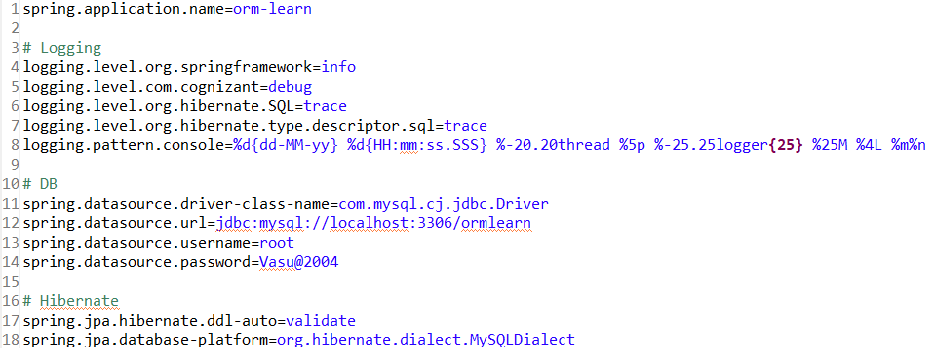

**OrmLearnApplication.java:**

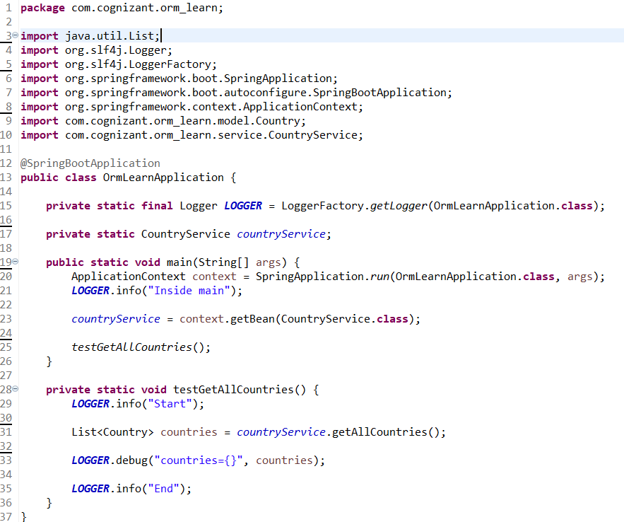

**Creating a Table “Country” in MySql Workbench under ormlearn Schema:**

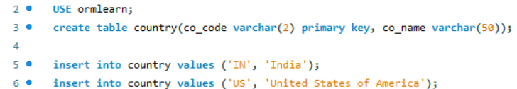

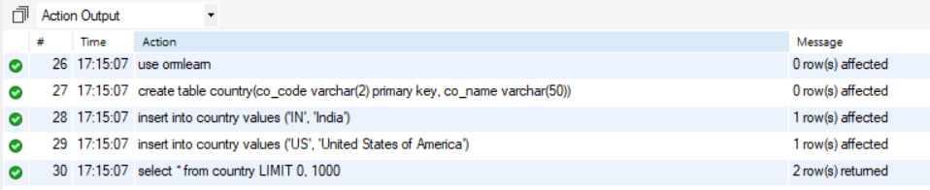

**Persistance class:**

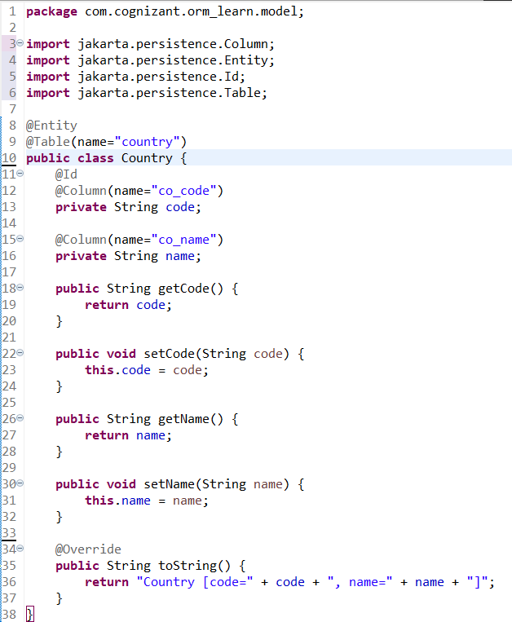

**Repository class:**

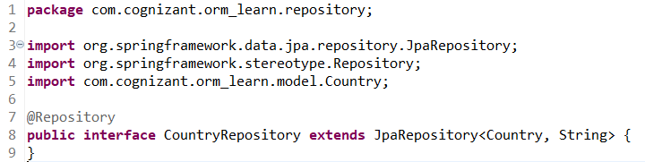

**Service class:**

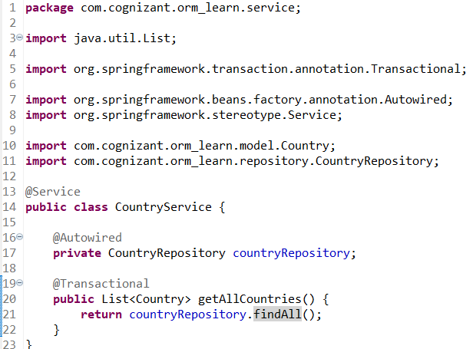

**OrmLearnApplication.java Testing output:**

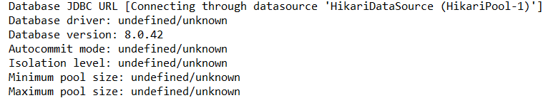

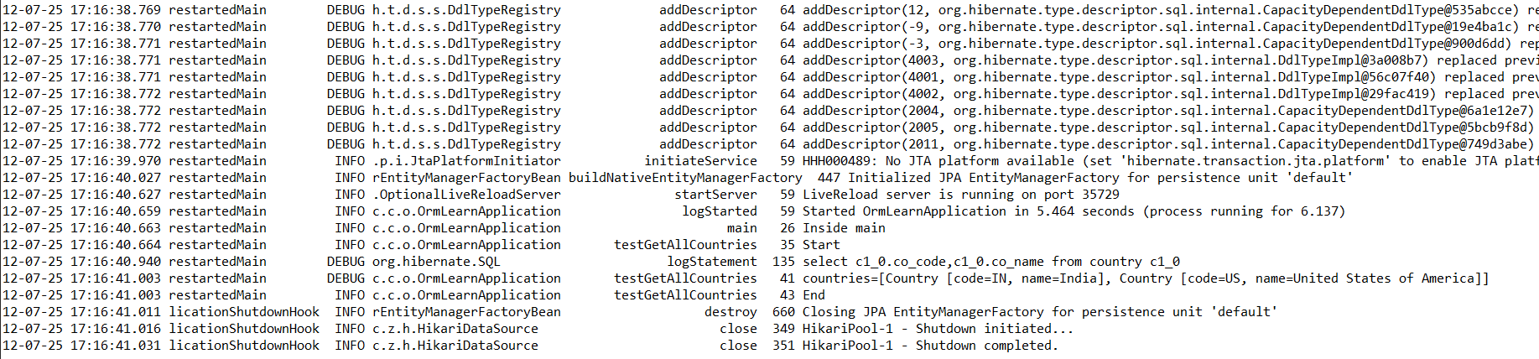

**Hands on 5**

**Implement services for managing Country**

**Country.java:**

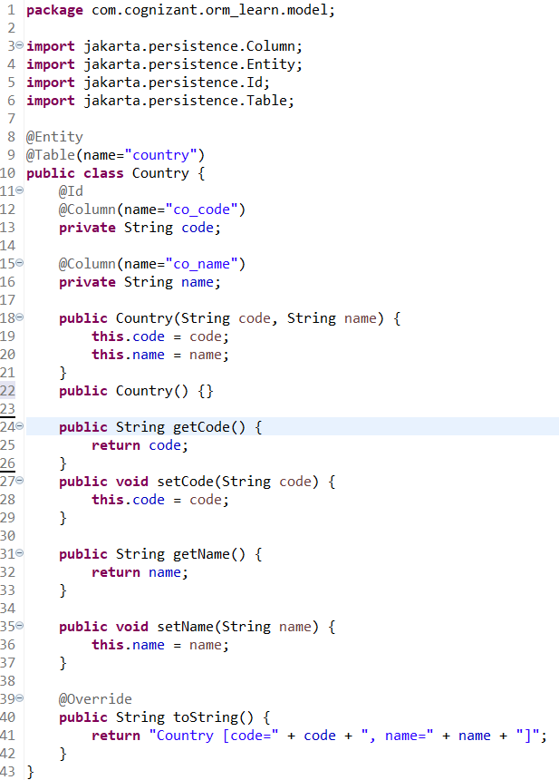

**CountryRepository.java:**

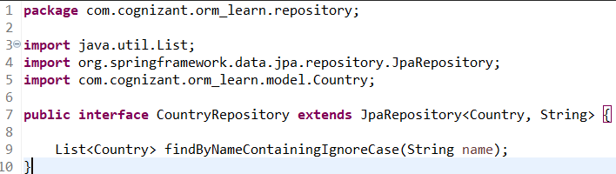

**CountryService.java:**

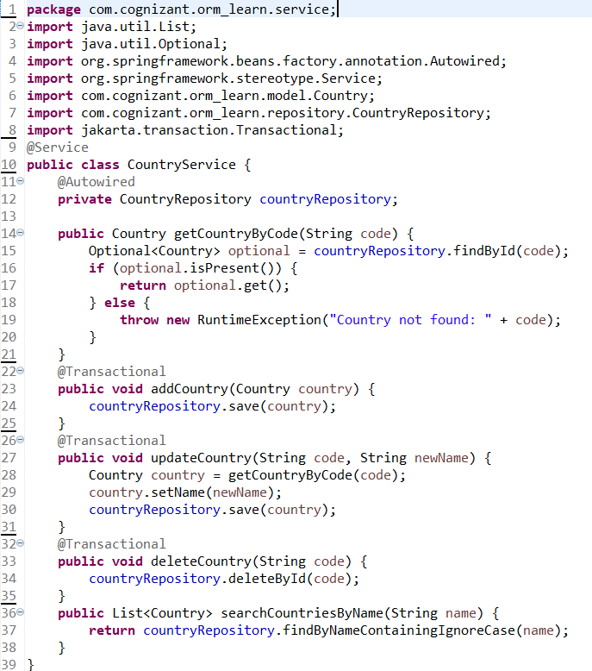

**OrmLearnApplication.java:**

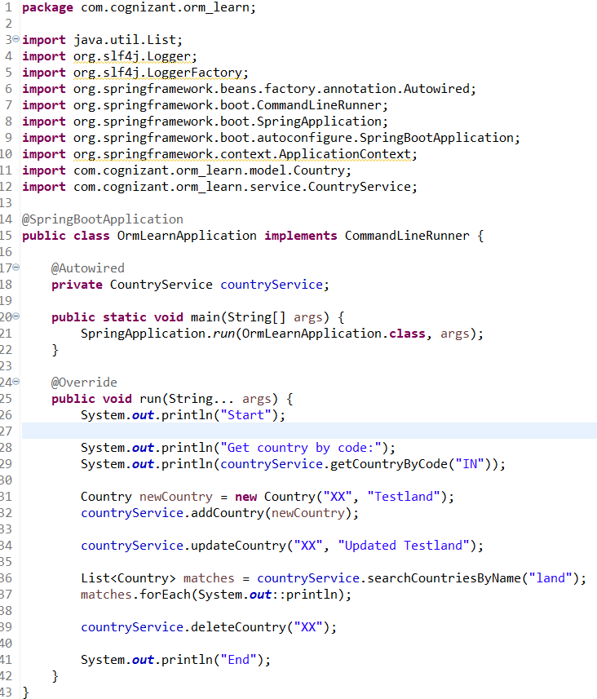

**Console Output:**

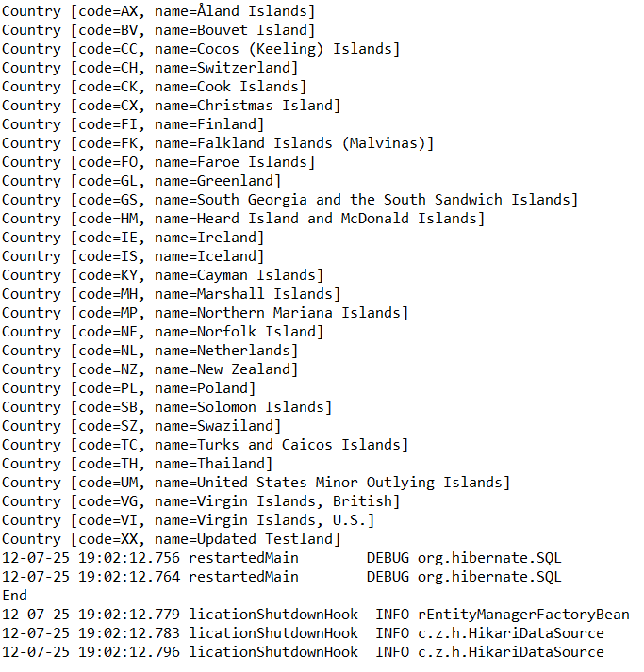

**Hands on 6**

**Find a country based on country code**

**CountryNotFoundException.java:**

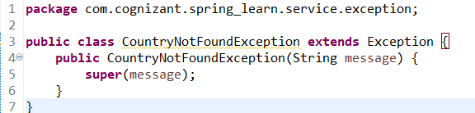

**CountryService.java:**

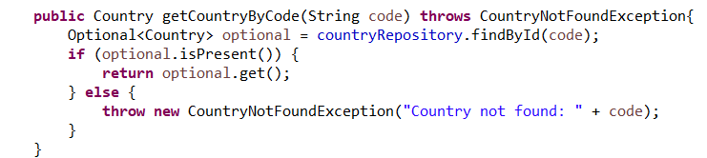

**OrmLearnApplication.java:**

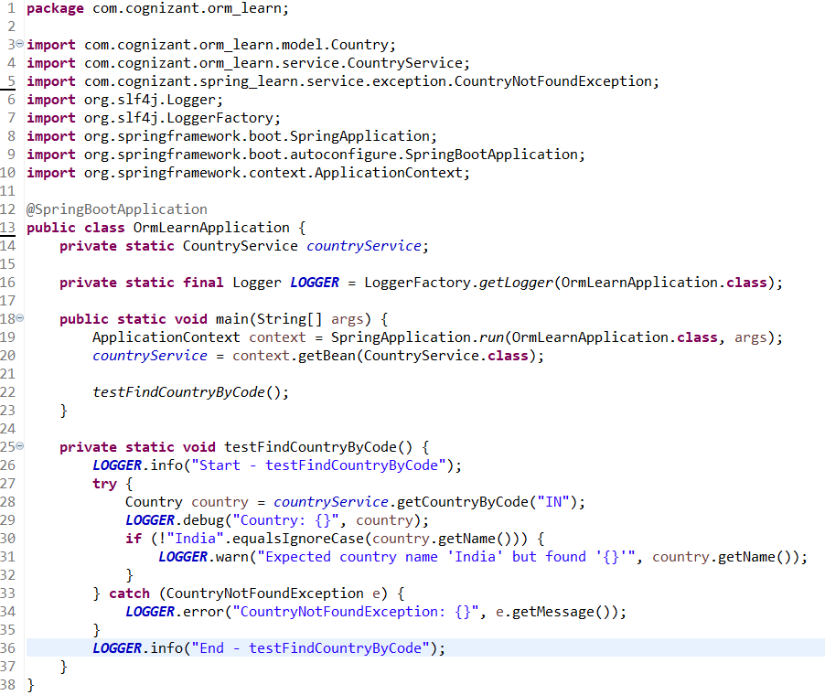

**Console Output: Displays the Country by the Country Code**

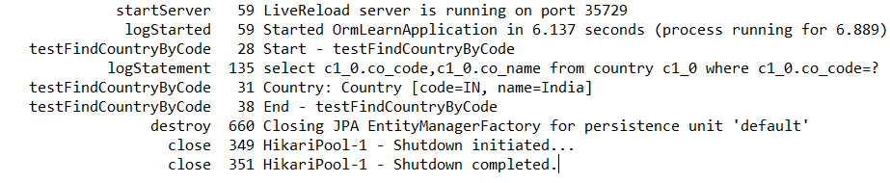

**Hands on 7**

**Add a new country**

**CountryService.java:**

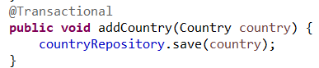

**OrmLearnApplication.java:**

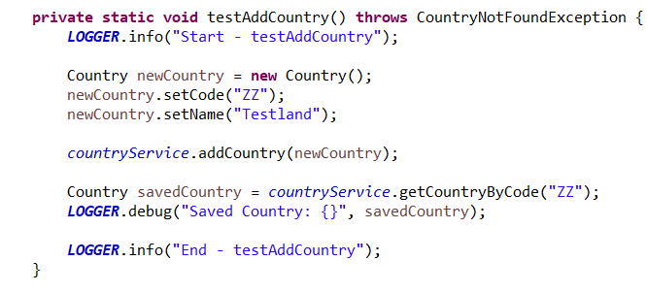

**Console output: Adds the new Country with Country Code to the CountryRepository**

